Material word cards
Instructions: Cut into individual cards and use to support thinking, discussions and recording.
plastic | 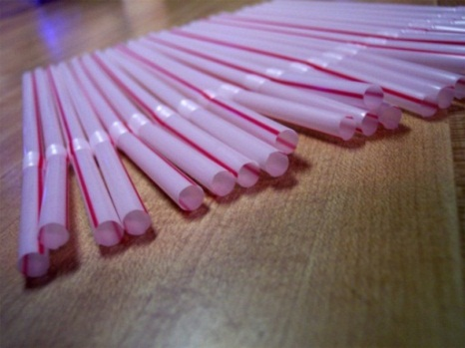  Cohdra, Straws1 http://www.morguefile.com/archive/display/28143
wood | 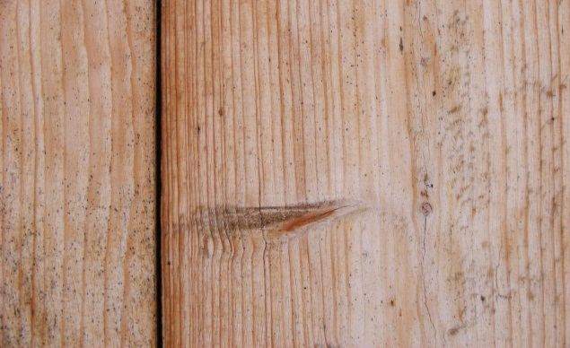  Bhjoco, DSCF0057 http://www.morguefile.com/archive/display/850465
glass | 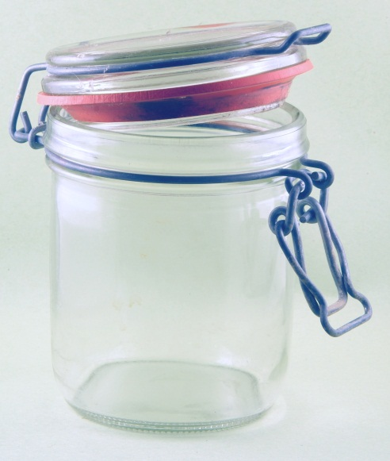  Jusben, Dsc04531_r  http://mrg.bz/y4Ew4x
metal | 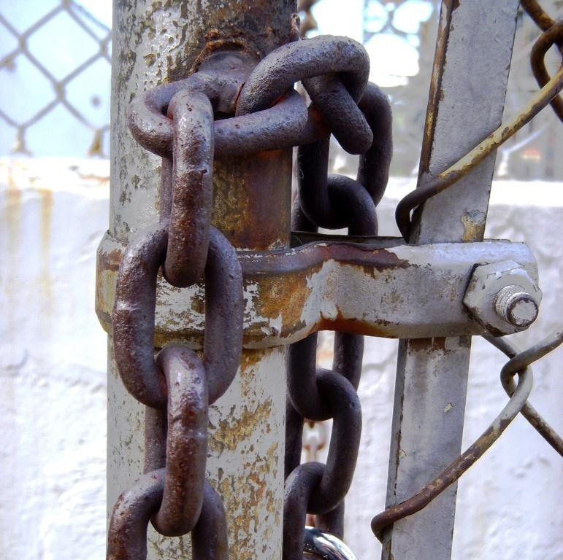  Krosseel, eee37  http://mrg.bz/wlplPe
polystyrene | 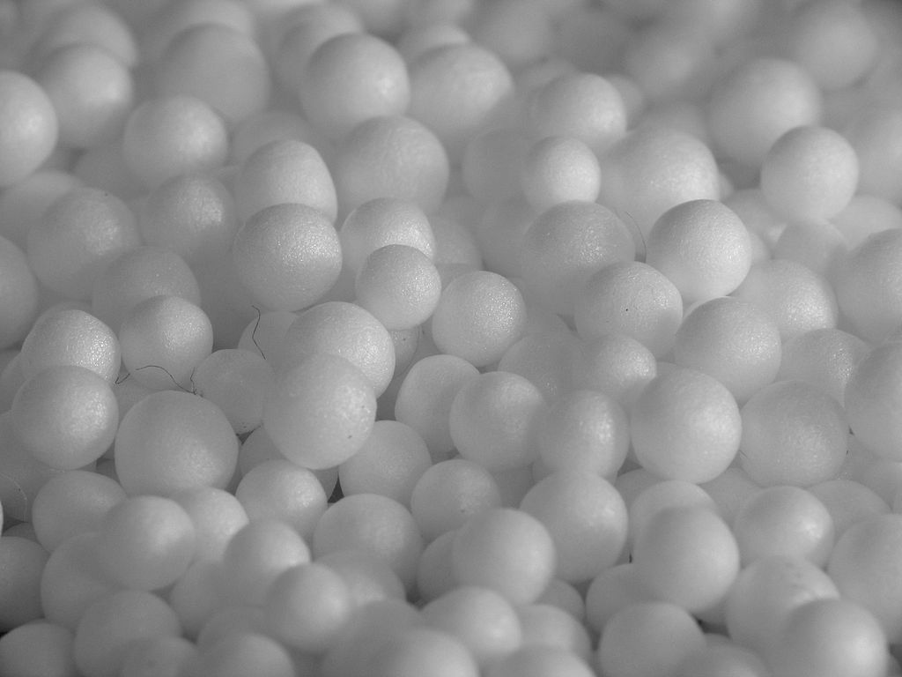  Sei, Styropian http://commons.wikimedia.org/wiki/File%3AStyropian.jpg CC-BY-SA 3.0 Unported, creativecommons.org/licenses/by-sa/3.0/deed.en
straw | 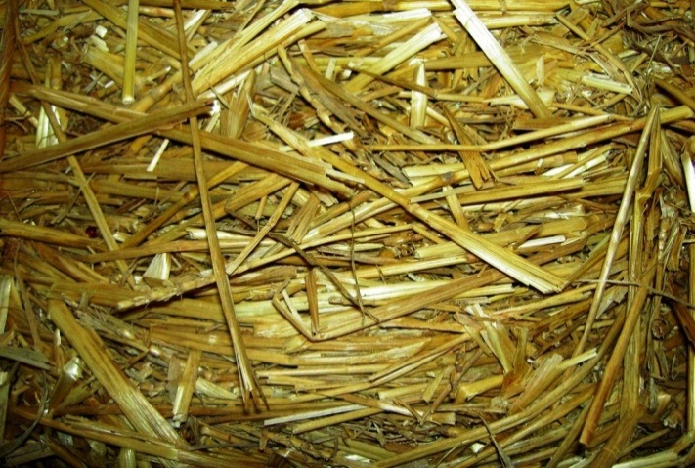  Jdurham, aafieldtrip 010a  http://mrg.bz/c0FPqd
aluminium | 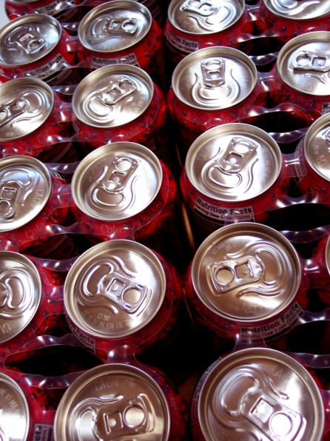  Cohdra, 100_4019  http://mrg.bz/l24JDS
paper |   Cohdra, 100_8654  http://mrg. bz/Qumw5g
ceramic |   Wax115, Kitchen_tools_11  http://mrg.bz/HojANi
fabric | 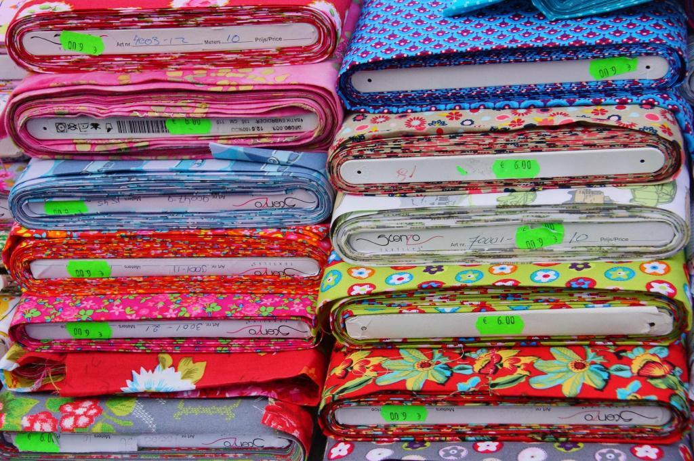  Jusben, Arnhem market Sep 20 2013 (3)  http://mrg.bz/gG2yep
cardboard | 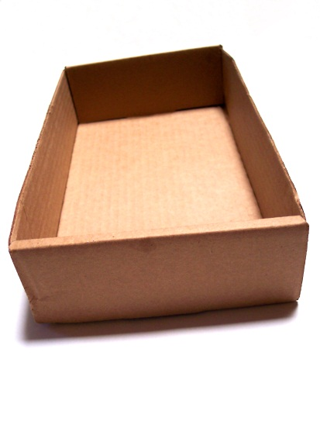  Cohdra, 100_3540  http://mrg.bz/7QWDoD
rubber | 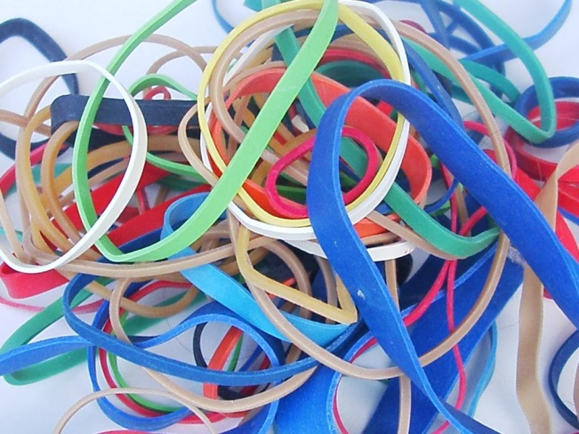  DuBoix, m4h9a2 025  http://mrg.bz/Wx1pcU
brick | 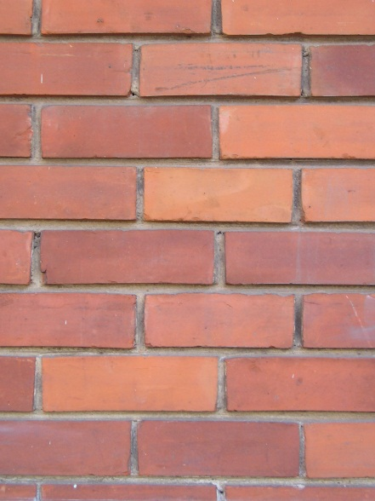  Alvimann, Texture_-_bricks_1  http://mrg.bz/legu2V
stone | 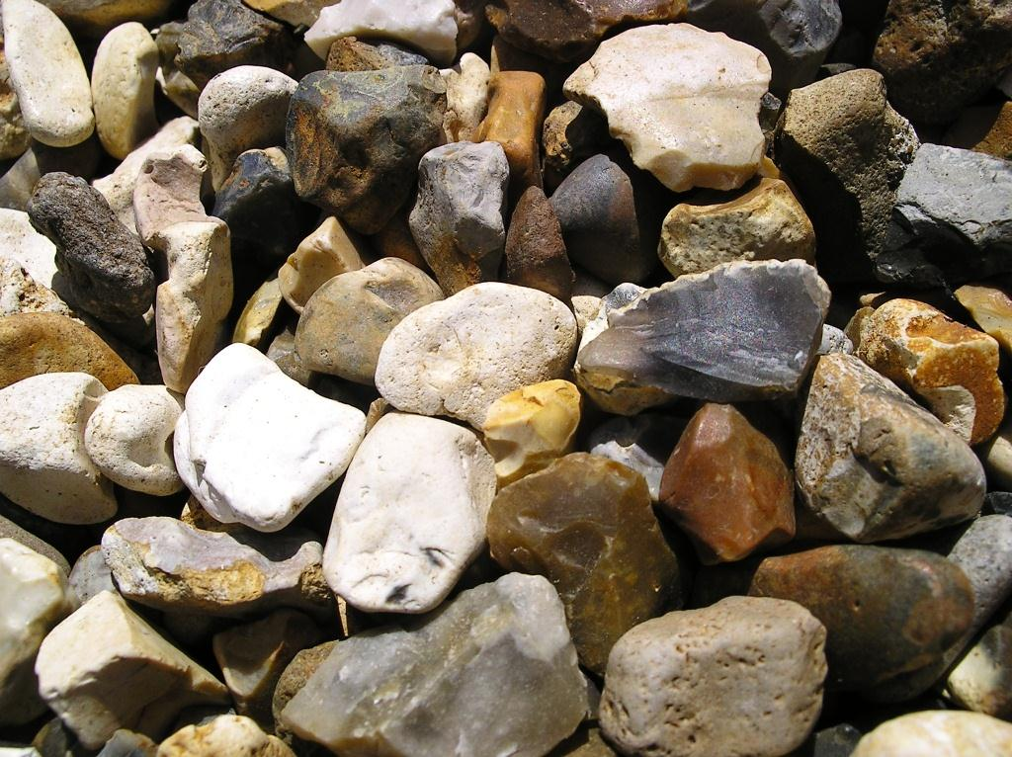  Pickle, IMGP6282  http://mrg.bz/BDvXAu
wool | 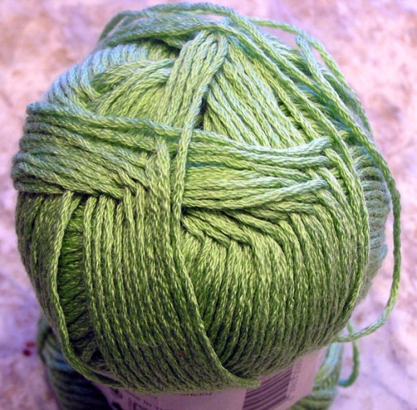  Beglib, Needle ready  http://mrg.bz/M5ZmNH
cotton wool | 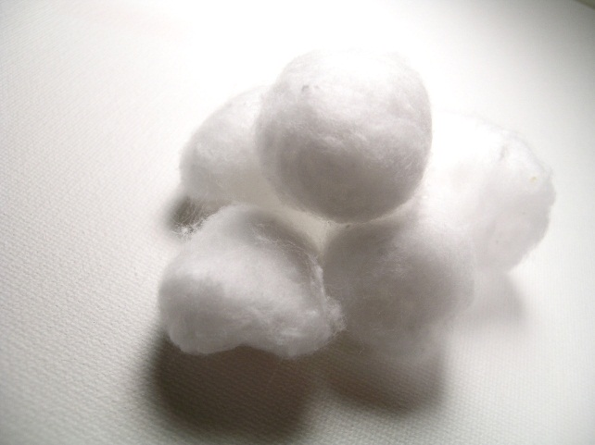  Jeltovski, mf88  http://mrg.bz/2EFntU

