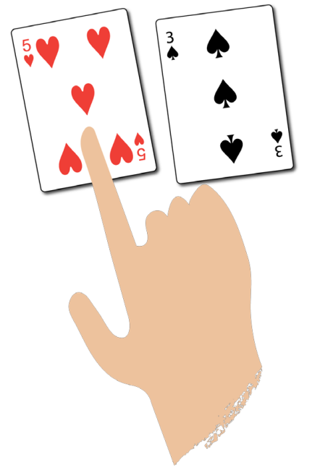**‘Sharing’ card games**

Highest number wins

**You need:**

2 or 3 players

‘Five is  
higher than  
three.’

A pack of playing cards – remove the jacks, queens and kings

**How to play:**

* Deal the cards equally to each player. Players put their cards face down  
  in a pile.
* Each player flips over the top card in their pile.
* The player with the highest number takes all the cards that have been flipped over  
  and puts them in a separate pile.
* If the numbers are the same, put the cards to one side. On the next round, the player with  
  the highest number takes those cards too.
* Play until all the cards in each player’s initial pile are used up. The player with the most  
  cards wins.

**Harder:** Each player flips over two cards and adds them together. He player with the  
highest total takes the cards played.

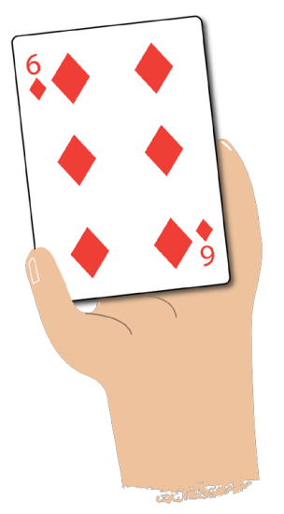

Highest number wins

**You need:**

2 or 3 players

‘Do you   
have a ...?’

A pack of playing cards – remove the jacks, queens and kings

**How to play:**

* Deal five cards to each player.
* Place the remaining cards in a pile face down.
* If players have two cards that make 10 (e.g. a 6 and a 4), put them down and pick up two  
  more cards.
* Players take it in turns to ask another player if they have a card that will go with one of their  
  cards to make ten (e.g. if a player has a 6 in their hand they will ask, ‘Do you have a 4?’)
* If players get the card they need, they put the cards down and pick up two more cards.
* Play until the all the cards in the pile are used up.
* The player with the most pairs wins.

**Easier:** Use number cards to 5 only.