**Part-part-whole creatures**

Make two different creatures with playdough. Use the following combinations of objects (iceblock sticks, buttons and straws) on your creatures.

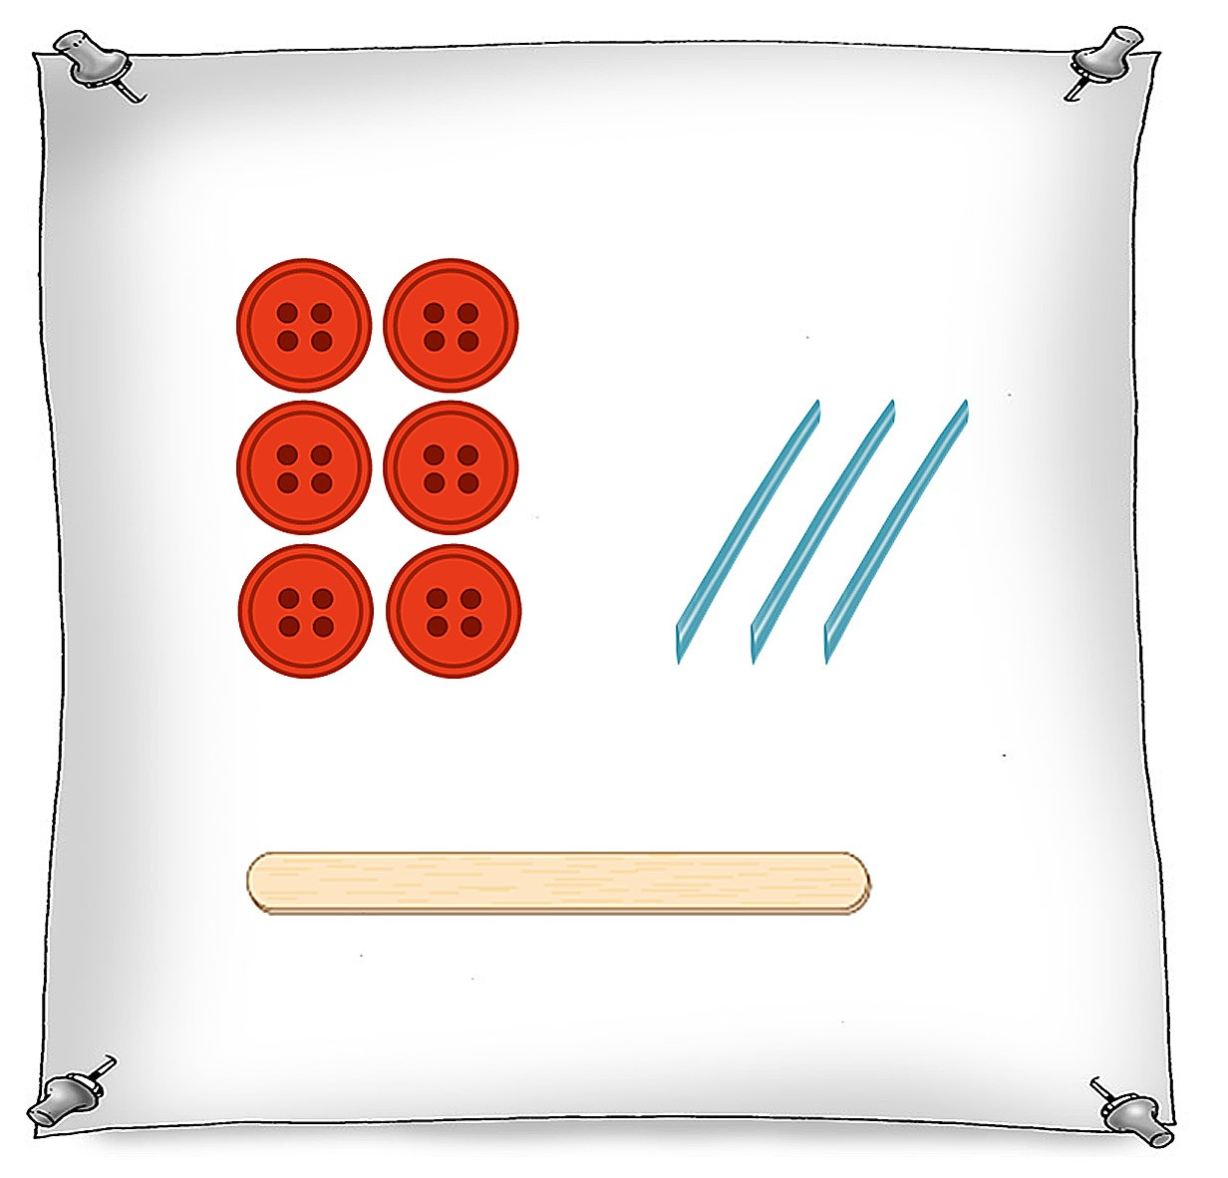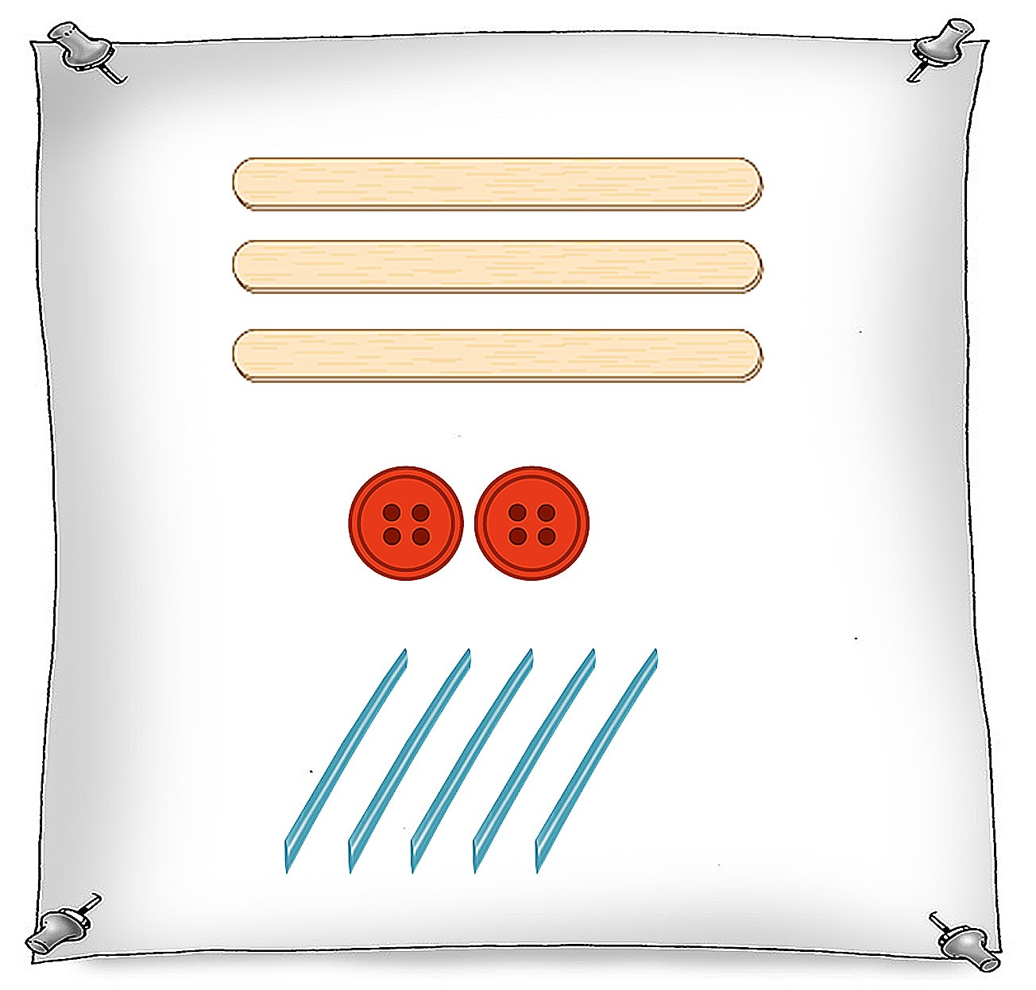

Make another creature with the same total of parts but use a different combination.

Plan the parts you will use by drawing them on this sign.

