**Counting rhymes**

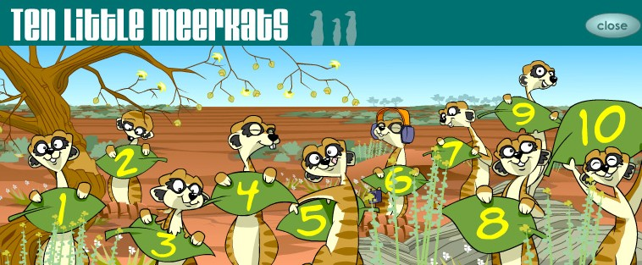

One little, two little, three little meerkats,

Four little, five little, six little meerkats,

Seven little, eight little, nine little meerkats,

Ten little meerkats in a row.

Ten little, nine little, eight little meerkats,

Seven little, six little, five little meerkats,

Four little, three little, two little meerkats,

One little meerkat,

Where’d they go?

One finger one thumb

One finger one thumb keep moving

One finger one thumb keep moving

One finger one thumb keep moving

We’ll all be merry and bright.

Continue the song and add a moving finger (or thumb) each time you sing a new verse, e.g

Two fingers, one thumb keep moving ...

Eight fingers, two thumbs keep moving …

|  |  |  |  |  |
| --- | --- | --- | --- | --- |
| 1, | 2, | 3, | 4, | 5 |
| 1, | 2, | 3, | 4, | 5 once I caught a fish alive |
| 6, | 7, | 8, | 9, | 10 then I let him go again. |

Why did you let him go?

Because he bit my finger so.

Which finger did he bite?

This little finger on my right.