**This is the way we...**

What to do:

1. Sing/say the song.
2. Add verses about activities completed during the day.
3. Sing the verses in order (from morning to night).

Examples of verses

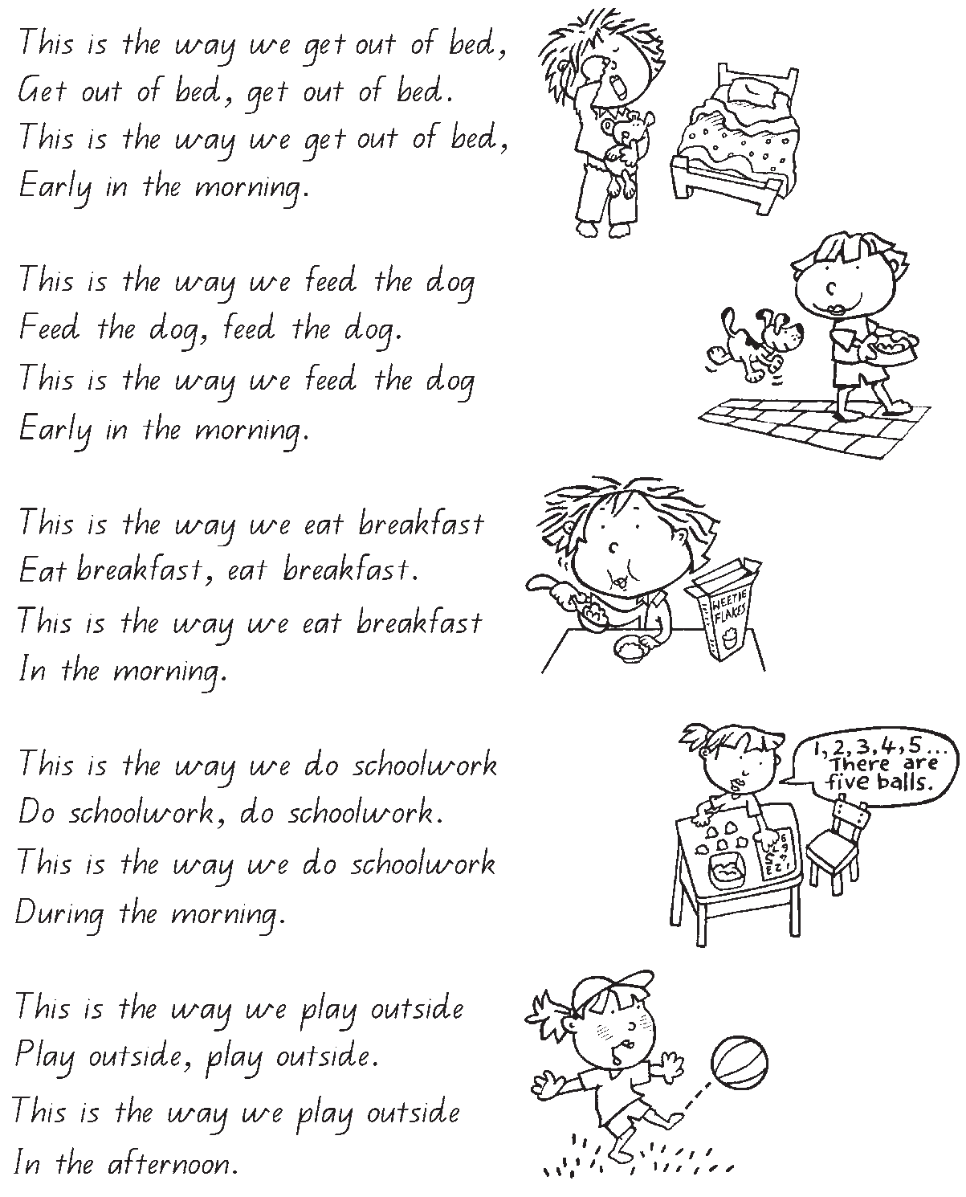

Some other possible verses

:

