**Photos: Going to school**

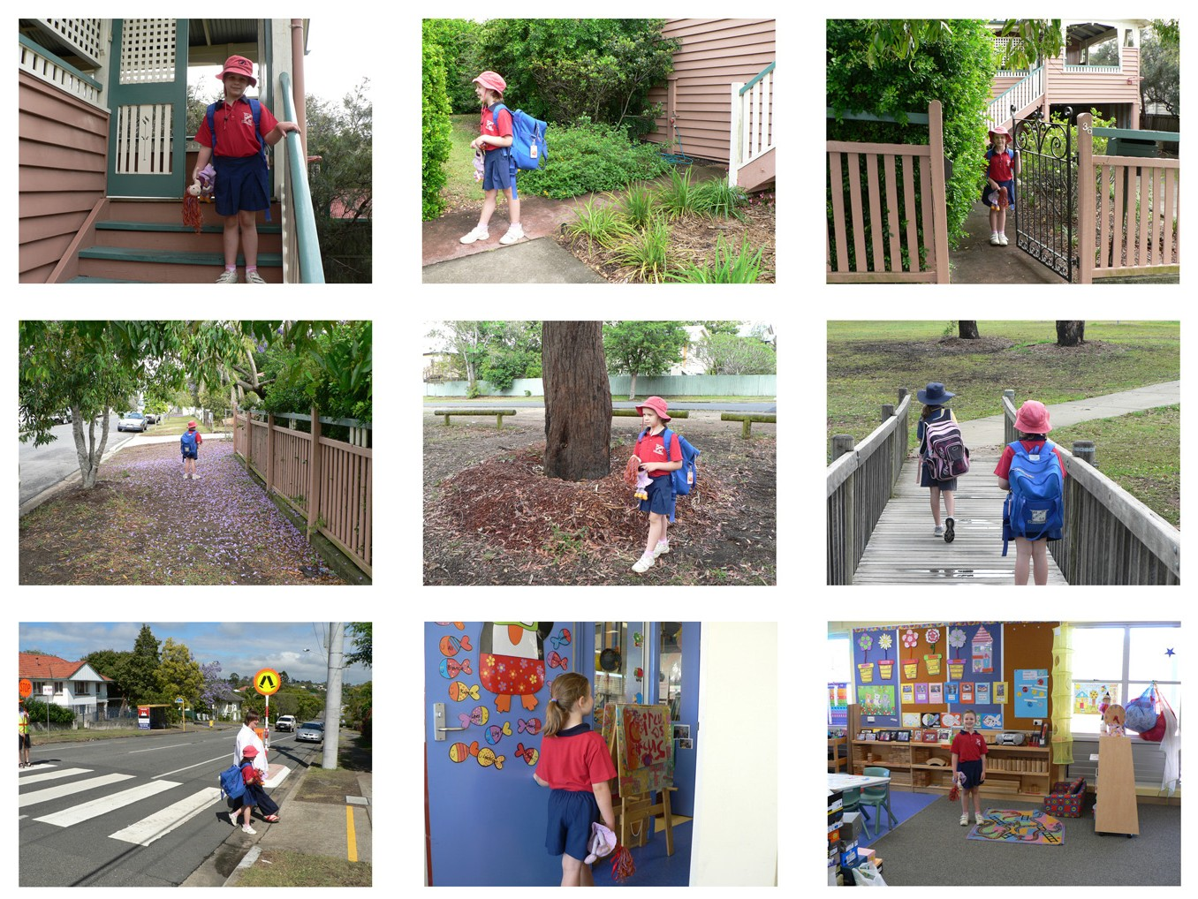

Persons appearing do so with consent.