My retelling planner
Title:
Author:
Beginning — Who and when?  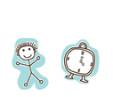 | What happened next?
What happened next? | What happened next?
What happened next? | 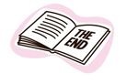  What happened at the end?
This story reminds me of when … (personal connection to the story)

