Retelling planner: Going swimming
Cut along the dotted line and join the sections together.
Title: Going swimming
Author: Abbey
Beginning — Who and when?  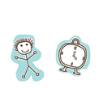 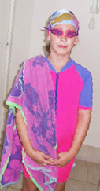  I went to the swimming pool on Monday | What happened next?  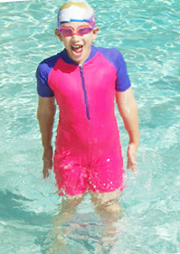  First, I jumped up and down in the water.
What happened next?  Next, I went diving for rings. 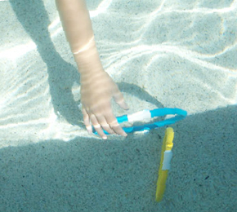 | What happened next?  Then, I swam on my back.  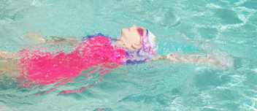
What happened next?  Finally, I swam across the pool.  | What happened at the end?  I like going swimming. 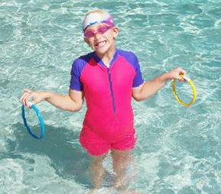  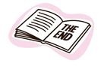
Persons appearing do so with consent.

